6115-MAHENDRA INSTITUTE OF ENGINEERING AND TECHNOLOGY

*NOISE POLLUTION MONITORING*

TEAM: PROJ_223288_TEAM_1

Team id: 570

Year: III

|  |
| --- |
| Team Members Name  YASVANTHRAJ.S  VIGNESHWARAN.M  VIGNESH.J  TAMIL SELVAN.A.D  SURESH.D  SURENDIRA BABU.D  Mentor Name  M.SANTHANARAJ |

Initialization

In this guide, we will explore the importance of noise pollution monitoring and its various types and effects. We will also delve into the methods used for monitoring noise pollution and discuss the benefits of implementing such monitoring systems. By the end, you will have a comprehensive understanding of why noise pollution monitoring is crucial in today's world.

**The Objective: Maintaining Serenity**

Noise pollution monitoring aims to preserve the tranquility of our environment. By measuring and analyzing sound levels, we can identify potential sources of noise pollution and implement appropriate solutions. Whether it is reducing traffic noise or minimizing industrial disturbances, the objective of noise pollution monitoring is to create a peaceful and harmonious atmosphere for all.

Understanding Noise Pollution

### Environmental Noise

Environmental noise pollution includes sounds from transportation, construction, and recreational activities. By monitoring these sources, we can mitigate their impact on both wildlife and human health.

### Industrial Noise

Industrial noise pollution arises from factories, generators, and machinery. By closely examining the noise levels in such settings, we can protect workers' hearing and ensure compliance with noise regulations.

### Community Noise

Community noise sources like loud music, barking dogs, and noisy neighbors can disrupt the peace of residential areas. Monitoring community noise allows us to address specific issues affecting local communities.

# Unmasking the Effects of Noise Pollution

|  |  |  |
| --- | --- | --- |
| Health Effects | Environmental Degradation | Social Disruption |
| Noise pollution can lead to stress, sleep disturbances, and cardiovascular problems. | Excessive noise can harm wildlife, disrupt ecosystems, and impact natural habitats. | Noise pollution hampers communication, contributes to irritability, and impairs concentration. |

# The Sound of Measurement

"The decibel meter, a vital tool in noise pollution monitoring, takes the whispers of the environment and transforms them into actionable data."

Through decibel meters and sound level monitors, we can objectively measure noise levels and establish baseline thresholds for different environments. These devices enable quantitative analysis and serve as the foundation for effective noise pollution management strategies.

# Elevating Noise Pollution Monitoring

#### Preventative Measures

By monitoring noise pollution, we can take proactive steps to minimize its occurrence through better urban planning, effective noise barriers, and technological advancements in noise-reducing equipment.

#### Regulatory Compliance

Noise monitoring is crucial in ensuring compliance with noise regulations, protecting public health, and maintaining a harmonious coexistence between industrial activities and communities.

#### Improved Quality of Life

Implementing noise pollution monitoring enhances the overall well-being of individuals and communities by creating quieter and more comfortable living and working environments.

# Data Collection and Analysis

"Data is the new oil." With noise pollution monitoring, data collection and analysis play a vital role in understanding the problem and developing effective strategies. By analyzing noise patterns, sources, and trends, we can make informed decisions and implement targeted solutions to combat noise pollution.

# Technology Used in Noise Pollution Monitoring

#### Sound Level Meters

#### Measure sound pressure levels in decibels (dB) and record data for analysis.

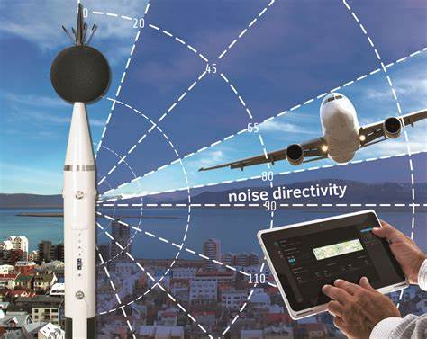

#### Noise Monitoring Software

Collects and analyses noise data, helps in generating reports, and assists in decision-making.

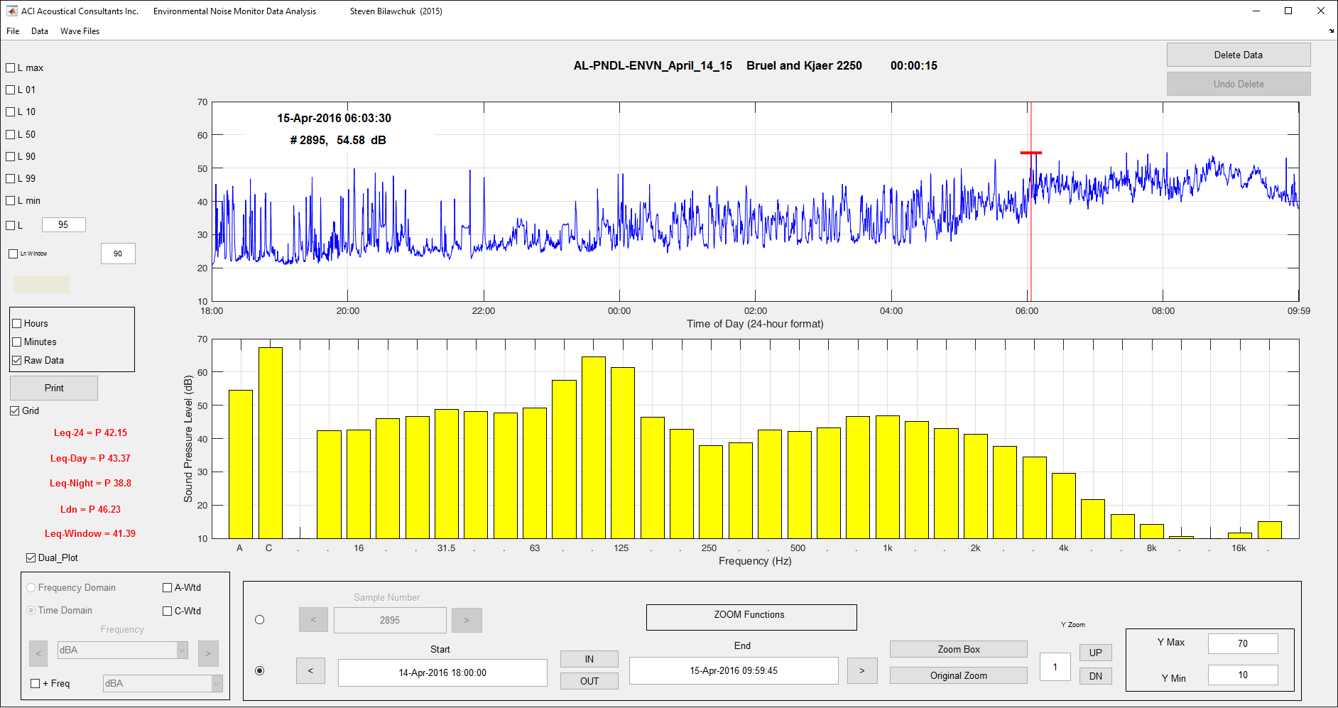

#### Noise Mapping Software

Visualises noise data by generating noise maps and helping in identifying noise hotspots.

# 

DATASET(JAVA)

import java.util.Scanner;

public class NoisePollutionMonitoring

{

public static void main(String[] args)

{

Scanner scanner = new Scanner(System.in);

System.out.println("Noise Pollution Monitoring System");

System.out.println("--------------------------------");

int noiseLevel;

// Variable to store noise level

// Reading and monitoring noise levels until user enters -1 to quit

while (true)

{

System.out.print("Enter the noise level (-1 to quit): ");

noiseLevel = scanner.nextInt();

if (noiseLevel == -1) {

System.out.println("Monitoring system stopped.");

break;

}

// Perform noise pollution analysis based on the noise level

if (noiseLevel <= 45)

{

System.out.println("Noise level is within acceptable limits.");

}

else if (noiseLevel > 45 && noiseLevel <= 70) {

System.out.println("Noise level is moderately disturbing.");

}

else if (noiseLevel > 70 && noiseLevel <= 90) {

System.out.println("Noise level is very disturbing. Take precautions!");

}

else

{

System.out.println("Noise level is extremely disturbing. Immediate action required!");

}

}

scanner.close();

}

}

OUTPUT

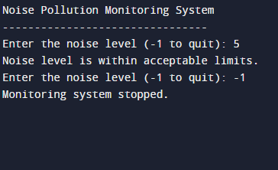

|  |
| --- |
| THANK YOU |